**Test Case 1 –** Sales Amount By SalesTerritoryCountry = Canada

Power bI Result -

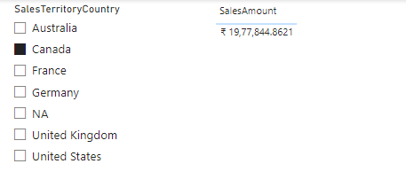

SQL Result-

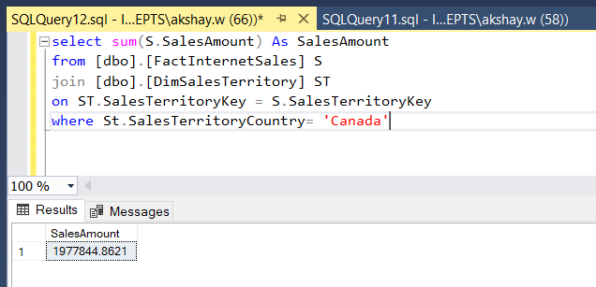

**Test Case 2 –** Order Quantity (Descending) by EnglishProductName

Power bI Result -

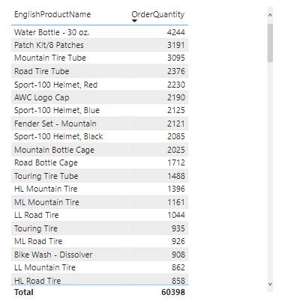

SQL Result -

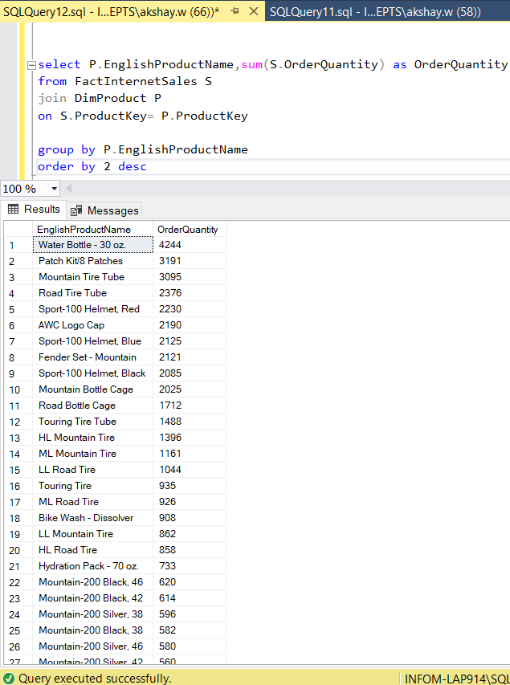

**Test Case 3 –** TaxAmount by CalenderYear

Power bI Result-

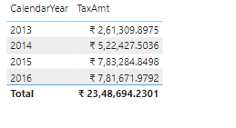

SQL Result-

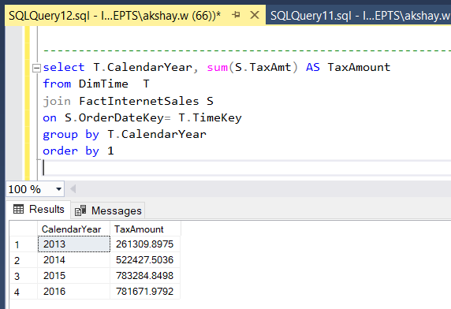

**Test Case 4 –** Top 5 City by SalesAmount

Power bI Result-

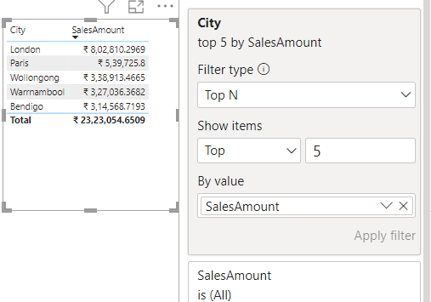

SQL Result-

